Friday, 18 September 2026, postcard

Avignon: a lazy day

The choice of morning excursions was a walking tour of the town that included a visit to the market with the chef and hotel manager, a tour of the papal palace, or a walking tour of the old town and Jewish quarter. David and I had already toured the palace on a previous trip, but he swore he didn't remember it, and it seemed like less walking, so he chose that one. Rachel and I were going to do the old town and Jewish quarter. But then they announced a fourth choice—a tour of the town in the little white train, with the option at the end of taking a taxi back to the ship. David still wanted to do the palace until they reminded him that (a) it's an empty shell, with nothing to see inside except architecture, and (b) touring it involved climbing (and coming back down) over 100 steps.

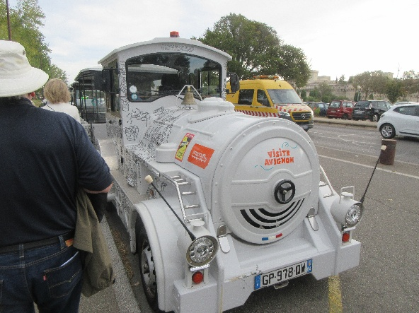
In the end, David and I took the little white train and the taxi. I was tempted to go on to the market alone, after the train, until I looked up its location—almost as far from the main square as the ship and in the opposite direction. Rachel stuck with her original choice.

The Avignon train is old-school, with the classic locomotive shape and the white color.

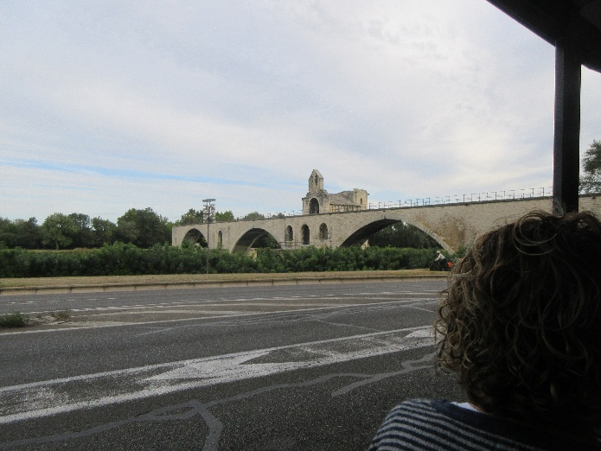
Here's the famous Pont d'Avignon, the only four arches still standing of the original 20 or so that spanned the Rhône from the city to the large island in the center, across the island, and on across the other branch of the Rhône to the far bank. And, yes, I have danced on the bridge (they play the song continuously there), and pretty tricky it was, too—those cobblestones are treacherous—but that was an earlier trip.

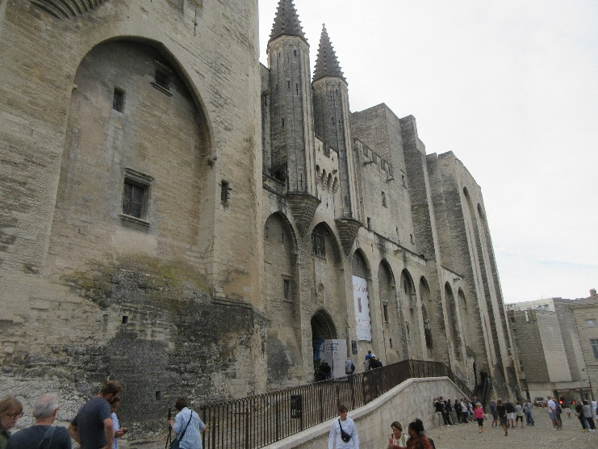
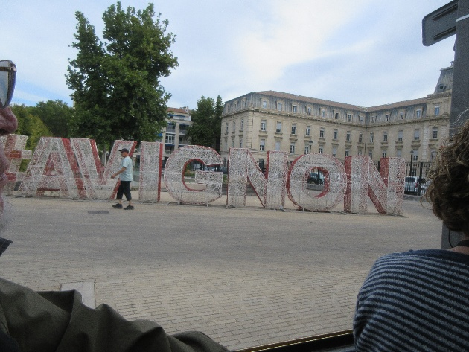
And here is the giant mesh city name that Avignon (like many other cities) has erected as a padlock magnet, trying to keep the locks off bridges and other structures where they can actually cause damage.

And finally, here's the façade of the palace, towering over the main square, where the train ride ended. We actually got back to the fast enough to have a little down time before lunch.

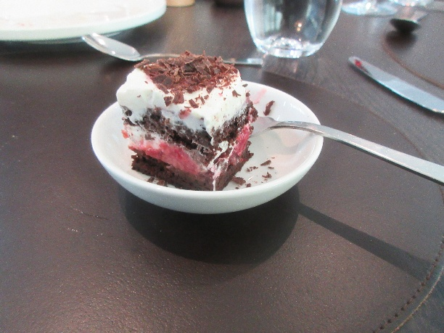
The standard of soups on this trip has been extremely high, but we didn't think lunch's carrot-ginger combination was quite up to par. David very much enjoyed his "blanquette de veau" (white veal stew). I had a tomato-based fish chowder, and the black forest cake was excellent.

The afternoon's activity was an onboard cooking demonstration of, are you ready?, vegetarian boeuf bourguignon—mushroom bourguigon. It was actually pretty good. It went together quite quickly, but then had to simmer for a long time, so after assembling the demonstration batch, the chef and his minions served a previously made batch, handing each of us (an hour after lunch and two hours before a promised banquet) a generous bowlful and a large hunk of bread.
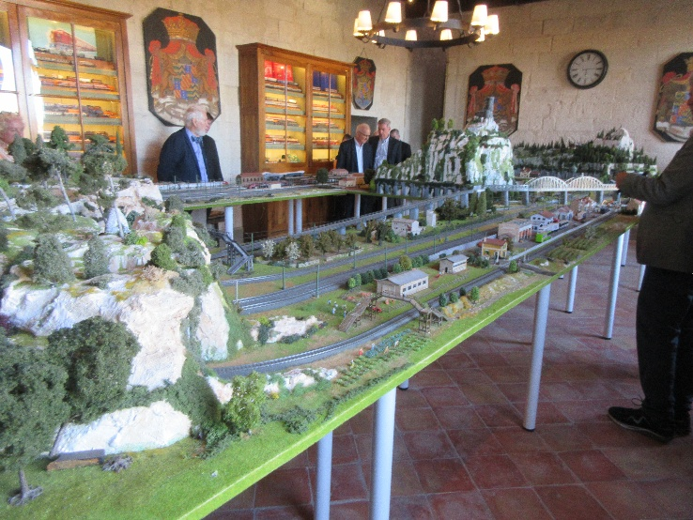
Dinner was at the Château d'Usèz. I'm pretty sure we once visited Usèz, just to see the town, but we'd never been to the château. The duke who lives there part of the time was not on hand to greet us, but we enjoyed chamber music in the courtyard, got to view his model train set-up, and enjoyed a delicious dinner featuring slow-cooked filet of veal.

